**INTEGRATION OF CO-SCHOLASTIC ACTIVITIES WITH SCHOLASTICS**

**TITLE : POWER OF MUSIC**

THEME: MUSIC AND LIFE

Name and Address of the School : THE HINDU SENIOR SECONDARY SCHOOL,

No.1, II MAIN ROAD, INDIRA NAGAR,

CHENNAI – 600 020.

Name of the Principal : Mrs.Padmini Sriraman

Name of the contributing teacher and students :

Teacher : Mrs. Uma Balasubramanian,M.Com., M.A.(Music), B.Ed., T.T.C.,Sangita Siromani

Students : 1.V S K Bhargavi Manogna

2. Shreemathi J

Contact details : hsssindiranagar@gmail.com

Table of Contents

I. Introduction

II. Identification of relationship between music and achievement

III. Analysis of the topic

IV. Objectives

V. Planning done

VI. Implementation & Challenges involved

VII. Resources-Teachers, musicians, musical instruments, questionnaires and ICT

VIII. Findings

IX. Evidences of Success[photos]

X. Beneficiary Satisfaction

XI. Concluding Remarks

XII. Glossary

XIII. Certificate of Originality by School Principal

XIV. Certificate of Originality by Author

XV. NOC

Executive Summary:

Music affects the way people function. It has an impact intellectually, morally, spiritually, and socially. As educationists, we need to prepare students mentally and physically so that they grow up to be balanced and productive members of society. While subjects such as maths or science are important, the extracurricular subjects too are important, especially music. Music should be promoted as an essential component of elementary and secondary education.

In every step of our lives music places another brick on the foundation of who we are. We sing hymns to help build our spiritual being, and patriotic songs to give us a sense of national identity. Music helps each one of us find our unique social niche, bringing us together with other people who share similar interests. Research on the value of starting music exposure and education for children has shown vast benefits for improving children’s creativity, sensitivity, motor skills and many aspects of their mental and cognitive abilities. We learn nursery rhymes that are designed to both entertain and educate us in our pre-school years, which help build the framework for the social and language skills we need to function in society. Integrating music in the school curriculum, be it science, math or language, enhances quality of education and improves learning and academic achievement.

**Introduction**

We, at The Hindu Senior Secondary School, have recognized the value of music exposure and education for all our students. This recognition has been the guiding principle for us to provide various opportunities for our students to learn music in school, develop their musical skills, participate in various music programmes and in the long term integrate music in the school curriculum formally.

**Identification of relationship between music and achievement**

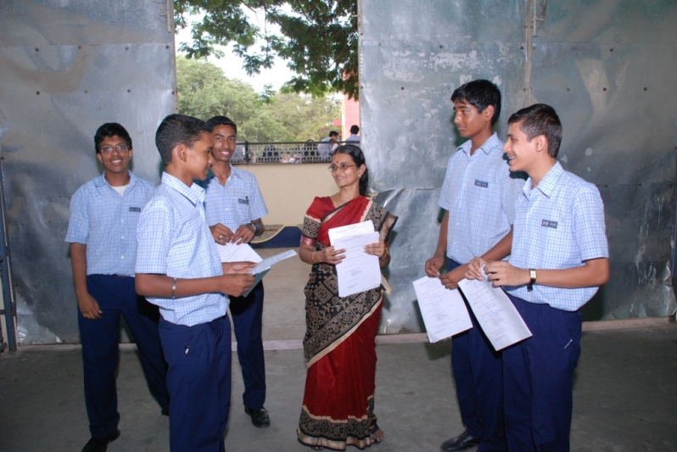The topic chosen for the Identification of relationship between music and achievement is a Comparative study of Western music and Indian music. Through this project students are exposed mainly to Western music and Indian Music as a part of their objective. One of the planned outputs from the project was to document the students’ experiences of music, its benefits for their lives and academic improvement and the added value of music in their lives.

**Analysis of the topic**

Indian music has influenced foreign music from very early times. Strabo in Book X says that the Greeks attributed to India nearly all their science of music. Alexander the Great took with him to Greece a South Indian musician centuries before Guido d’Arezo of the tenth century A.D. India has developed an excellent solfa system. The European tonic solfa notation owes its origins to the Indian system. The one gift of Europe to the music of South India is the violin. It was in the latter part of the 18th century that the first European violinist came to India. The Indian musicians carefully learned the method of play and immediately saw the tremendous possibilities. In European music violin is tuned in fifths and in Indian music fourths or fifths according to the composition. In South India, violin has become indispensable in a concert.

**Objectives**

The main objective of the project is to impart Western music and Indian music to the children. The project also aims to integrate music education in school and provide exposure and opportunities for enhancing student’s development and support their academic education.

Through the programme we hope to make students understand the differences and intricacies of Western and Indian music, provide exposure to both systems as well as find ways to integrate the two musical genres in performances. The programme includes students who have been learning music for some time, as well as those who have learned music less formally, but are very interested in music.

**Planning done**

As a part of our project we plan to take a number of different activities, some of which include:

* Classes on music theory and history for students, integrated with regular classes
* Cultural competitions with special emphasis on performance of both Indian and Western music by students
* Competitions called ‘Junk’ music or ‘Kitchen chronicles’ where students using the available utensils in an Indian kitchen performed musical programs
* Assessments among students to understand students’ perceptions and interest and to further develop them in the Western and fusion styles
* Events with fusion music performances
* Interaction and exposure to experts in the field of music

**Implementation and challenges involved**

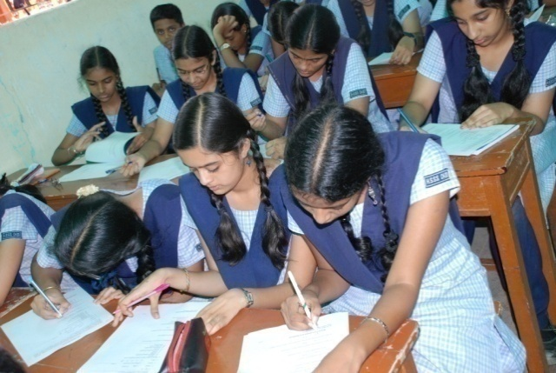Different approaches were taken up for documenting the voices and experiences of students. These included quantitative approaches such as a survey among students and other qualitative approaches such as personal interviews, questionnaire and essay writing.

A questionnaire was developed in English with questions on students’ background, their interests, learning, practice and interest in different types of music, perceptions of benefits of music and other related questions. A random survey was conducted among students who had been exposed to music project and / or were learning music. A snow-balling approach was used to do the survey. A select number of students learning music were asked to identify 3 to 5 other students in the school, who were also learning music / exposed to the project. All of them were then asked to complete a structured questionnaire in the month of July 2009.

**Sample Questionnaire**

This is an assessment to understand your interest and views about music. All the information provided in this will be used for the purpose of building knowledge on how music helps children. For those of you filling this, we request that you answer these questions as truthfully as possible. You can choose to not respond to any of these questions if you don’t wish to. Thank you.

-----------------------------------------------------------------------------------------------------

1. Age
2. Gender: a. Male b. Female
3. School: a. Hindu Senior Secondary b. Other __________________
4. Class: 6th 7th 8th 9th 10th
5. Personal hobbies (Select as many as applies to you)
   1. Dancing
   2. Singing or playing instrument
   3. Reading
   4. Writing
   5. Outdoor activities and games
   6. Drawing
   7. Internet and video games
   8. Listening to music
   9. Other specify

_______________________________________

1. a. What genre of music do you like the most?

b. Can you explain why?

1. Are you learning any type of music presently?

a. Yes b. No

1. For how long have you learned music?
   1. Never learned music
   2. Less than one year
   3. 1 to 3 years
   4. 3 to 5 years
   5. More than five years
2. What type / s of music have you learned? (tick as many answers as applicable)
   1. None at present
   2. Indian classical
   3. Indian folk
   4. Indian popular
   5. Western classical
   6. Western popular
   7. Other specify _________________

**Note: If not learning any western music then go to question 10 b**

1. a. What was the main reason that you decided to learn western music?

**Note: Those who answered question 10 a can go to question 11**

10. b. What is it that you like about western music?

1. a. Are you learning vocal or instrumental music

a. Vocal b. Instrumental

b. If Instrumental what instrument/ s?

_______________________ _____________________

1. Are you also learning music theory?

a. Yes b. No

If yes what grade or level or you at presently?

_______________________________________________________

1. Have you passed any exams in music theory or practical?

a. Yes b. No

1. Have you performed / given any concerts in your school or else where?

a. Yes b. No

**IF no to above question go to Question 16**

1. How often have you given such performances?
   * 1. Once or twice so far
     2. Number of times in the last year _______
2. a. What is your favorite western music?

b. Why do you like this?

1. a. What is the instrument that you like the most?

b. Why do like this?

1. What are the differences between Indian and western music? Can you give three differences that come to your mind?
   * 1. _______________________________________________
     2. _______________________________________________
     3. _______________________________________________
2. a. Are you learning music do to your own interest?

a. Yes b. No

b. If no, on whose urging are you learning music?

1. What are the goals that you have set for yourself from learning music? (select only one of the below responses)
   * 1. Just a hobby and not set any goals
     2. Become a musician
     3. Become a music teacher
     4. Other Specify

___________________________________________

1. Other than the goals above, how do you think music will be useful in your life?

Give two or three useful ways

a. ___________________________________________________

b. ___________________________________________________

c. ___________________________________________________

1. Do you believe that you can achieve the goals that you have set for learning music?

a. Yes b. No

1. What are the main barriers for your learning music?

a. ___________________________________________________

b. ___________________________________________________

1. Who are all the people who support you in learning music?

a. _________________________________________________

b. _________________________________________________

1. Who is you most favorite musician?

___________________________________________________

1. How has music helped in your academic life?
   * 1. Not sure
     2. Not helped me much
     3. Has improved my memory
     4. Has improved my concentration
     5. Helped to score better marks
     6. Other specify

______________________________________________

1. How far do you travel to learn music?

_________________________________________________________

1. How much money do you spend every month for music?

_______________________

1. How much time do you spend per week (hours) listening to music?

______________________

1. How much time do you spend per week (hours) practicing music?

_______________________

1. Do you think that music is a disturbance to your studies?

a. Yes b. No

1. What would you consider as an achievement in music?

__________________________________________________

1. How important do you think learning music is for one’s development?
2. Not so important
3. Important
4. Very important
5. Not sure
6. What values do you think it gives to a person?

___________________________________________________

1. In your view do you think that music will / can help to change a person’s attitude or behavior?

a. Yes b. No

1. Which of the following things do you think music can do for a young person?
   * 1. To be calm and patient
     2. To think clearly
     3. To communicate or express oneself better
     4. To be more creative
     5. To be happy and cheerful
     6. Other specify

______________________________________________

1. Finally, we would like to hear in your own words, how you define music?

a. ________________________________________________

b. ________________________________________________

1. After learning music what are the changes in yourself?

a. ________________________________________________

b. ________________________________________________

1. What benefits have you felt as a result of learning music?

a. ________________________________________________

b. ________________________________________________

**Essay competition**

In order to compile qualitatively expressions, students participated in an essay writing competition, on a set of given topics and voiced their different views and perceptions about different aspects of music and how it has touched their lives.

**Video documentation**

To complement the report, we decided to document the experience of the project on video for wider distribution to tell others the story of how our music education project was taken up and helped the students in the school.

**Findings from students’ survey**

**Profile of Students***:*

We conducted the survey among a total of 130 students; of those who participated 43% were boys and 57% were girls. By age, 30% of students in the survey where 10 through 12 years, 65.4% were 13 through 15 years and remaining were 16 years old.



By class, 27% of students were in 6th -7th, 48% in 8th – 9th, and remaining were in

10th – 11th classes.



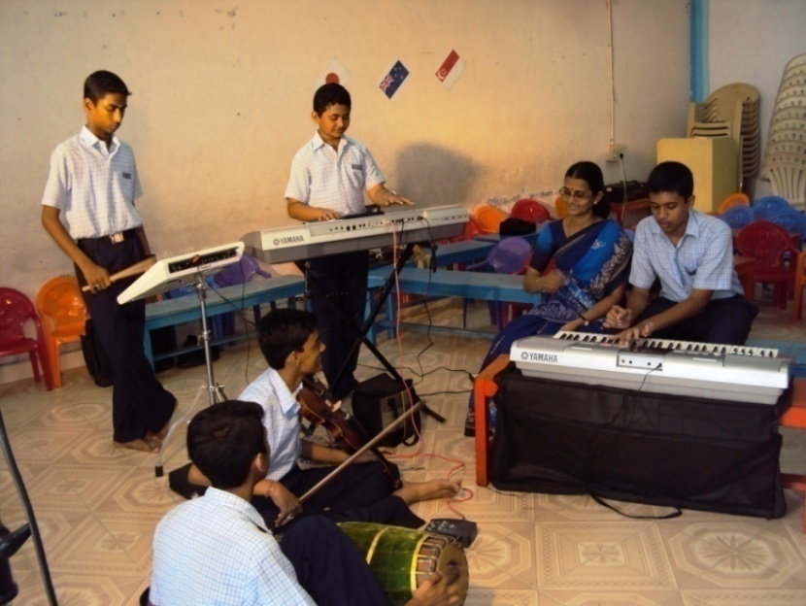From the survey we learned about the students hobbies. It was interesting to note that the singing or playing an instrument was a most favorite among students (88%) followed by reading (54%) and dancing (35%).

**Music - defined by students**

We wanted to know how students perceived music and asked them how they would define music in their own words.

**Students’ interest in music**

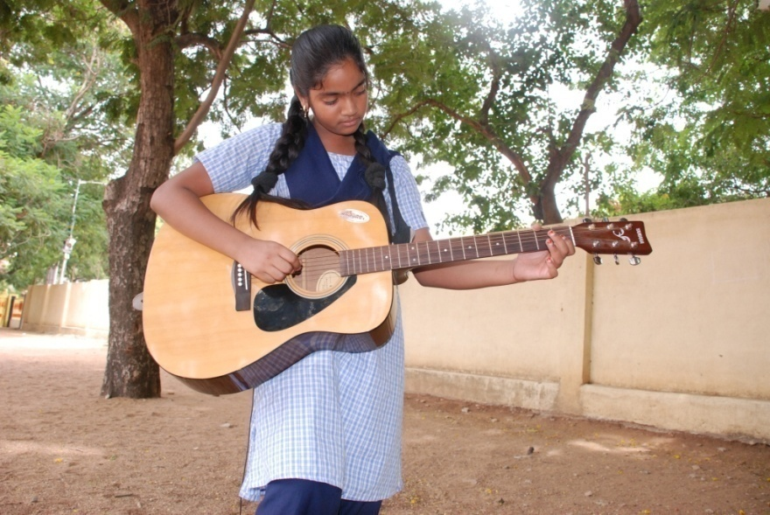Western music was a great favorite among students. On the genre of music liked most, a similar proportion of students reported liking music of Indian origin (48%) or Western music (44%) like Rock, Jazz, Hip-Hop, Pop or other Western music (44%) and others who liked all kinds of music.

The most common type of Western music that students liked were Rock (18%), Pop and melodious songs (30%). Even while 29% did not give any answer to this, the remaining said they liked a combination of Rap, Hip-Hop, Classical music, Country music or some type of instrumental music. Instruments such as keyboard and guitar were clearly a favorite among students who liked instrumental music.



When probed, the most common reasons that student reported for liking Western music were the quality of the voices, the quality of singing, the melodies, the rhythm and beats, the uniqueness of the sounds and most of all the energy in the music.

Other aspects that seem to draw students to Western music were:

* Use of chords
* The full rhythm, beats and the way the instruments are used
* The use of harmony
* Use of Piano
* The liveliness and the energy that it brings

Some students expressed that they liked the creativity in Western genres and the way harmony is used in the musical compositions. One student was very much inspired by Michael Jackson, whose influence made him get into Western music.

When asked about their favourite musician, 35% reported AR.Rehman (Indian musical maestro), while the remaining reported a combination of some Western classical or popular artist and Indian classical or popular artists. The favourite musician list included names such as:

|  |  |
| --- | --- |
| **Western Musicians** | **Indian Musicians/Singers** |
| The Blues | Ilayaraja, film music director/singer |
| Michael Jackson | Bombay Jayashree, musician |
| Mozart | Nithyashree, musician |
| Beethoven | SP Balasubramaniam, singer |
| James Bourne | K.J. Yesudas, musician |
| Bryan Adams | Shankar Mahadevan, musician |
| Eagles | MS Subbalakshmi, musician |
| Bach | RaviKiran, musician |
| Yani | Subha Mudgal, musician |
| Enrique Iglesias | Hariharan, singer |

**Learning & practice of music:** At the time of the survey 75% were learning music.



Thirty six percent of students were learning music for 1 to 3 years, 16% for less than one year, and 42% for more than 3 years. About five percent of students had not learned music formally. We collected further details about the types of music students were learning. Overall, 50% were only learning vocal music, 35% of students were only learning instrumental music and 15% both vocal and instrumental music. About 42% of students were learning only Western music while others were learning a combination of both Indian and other Western types of music.

Learning Western music appealed to students for various reasons such as:

* It is attractive and entertaining
* It is popular and famous world wide
* The original feel in Western music
* Having a passion for it
* Having a flare for Western music
* The rhythm and beat in Western music

A few students expressed their aspiration to learn Western music due to the exposure of the great composers like Beethoven.

Among those learning Western music, nearly one third were learning music theory and 15% had passed music theory exams.



**Beneficiary Satisfaction**

The students were the beneficiary of this project as it enabled them to understand music and its relationship with day to day life. They also were made aware the power of music not only for recreational purposes but also to enhance their academic excellence.

**Concluding Remarks**

A wide variety of responses indicated that students were indeed able to feel the essence of what is music. The most common responses were:

* Music is life, present everywhere
* It is something indescribable, which can be heard and felt but cannot be seen
* It is the expression of one’s inner most feelings
* Music is a tool to attain salvation and reach God
* It is a universal language which is divine
* Music is something which makes people hear and feel themselves and those that were based on technical understanding
* Music is the rhythm of life
* It is the perfect synchronization of pitch, notes and beats
* Music is time with different notes arranged in an order
* Music is the reflection of one’s emotions
* Music is a tune that pulls together everyone towards it self

**Glossary**

Hymns - a song of praise to God, a god, or a saint

Solfa - western musical notes

Intricacies - details

kitchen chronicles - music with utensils used in kitchen

Fusion - combination of different genres of music

Chord - playing or singing notes which are in unison

Harmony - singing or playing scales which are in accordance

***********************

PHOTO EVIDENCES

